**Instructions to publish Azure function and to create customer connector to call it in flow**

**Step 1**: After creating Azure function publish it by creating publish profile

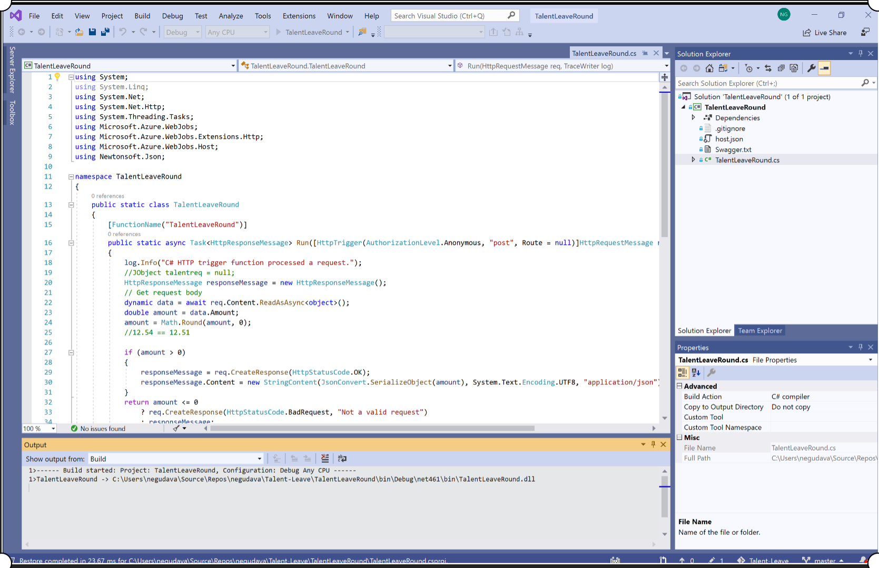

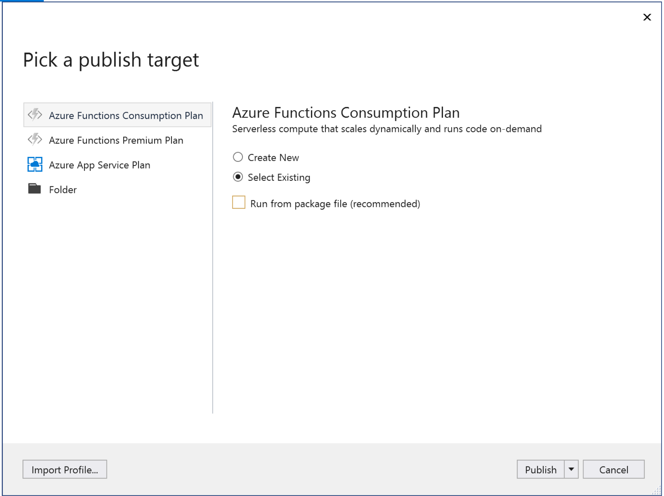

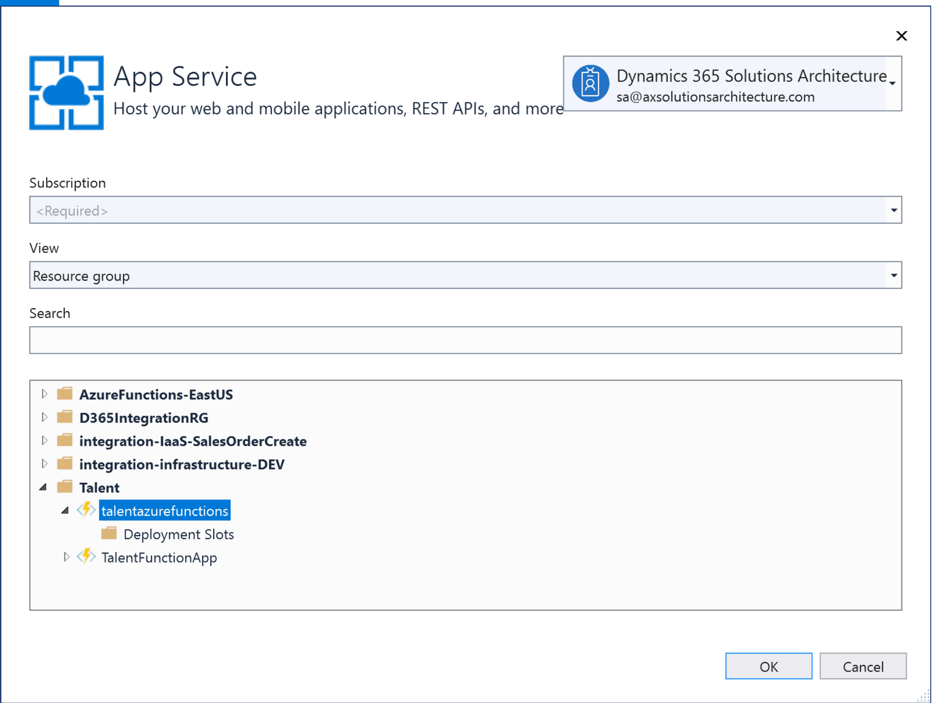

**Step2: Change the published function settings in Azure portal from Read to Read/Write as well as change version; Final settings should reflect settings in Screenshot 2 and 3**

**Change Website_Run_From_Package to 0 from 1**

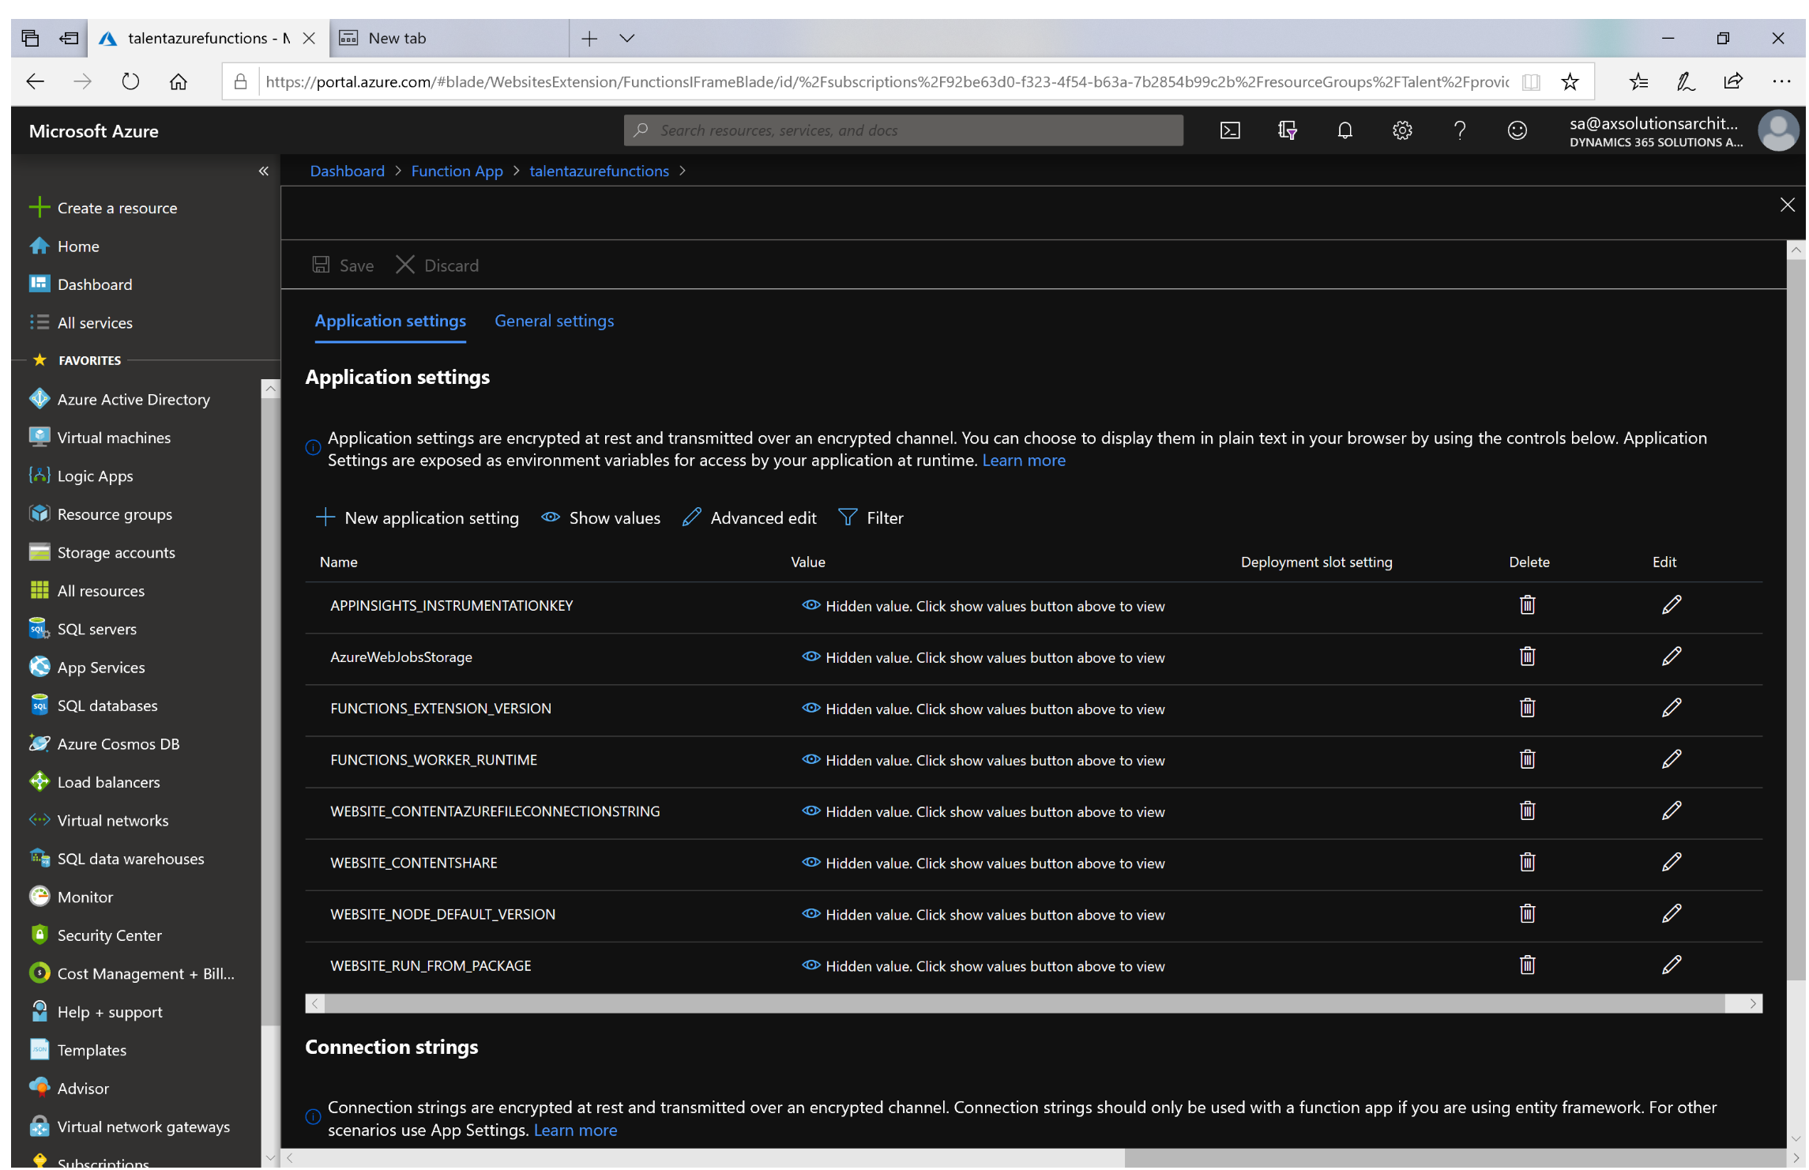

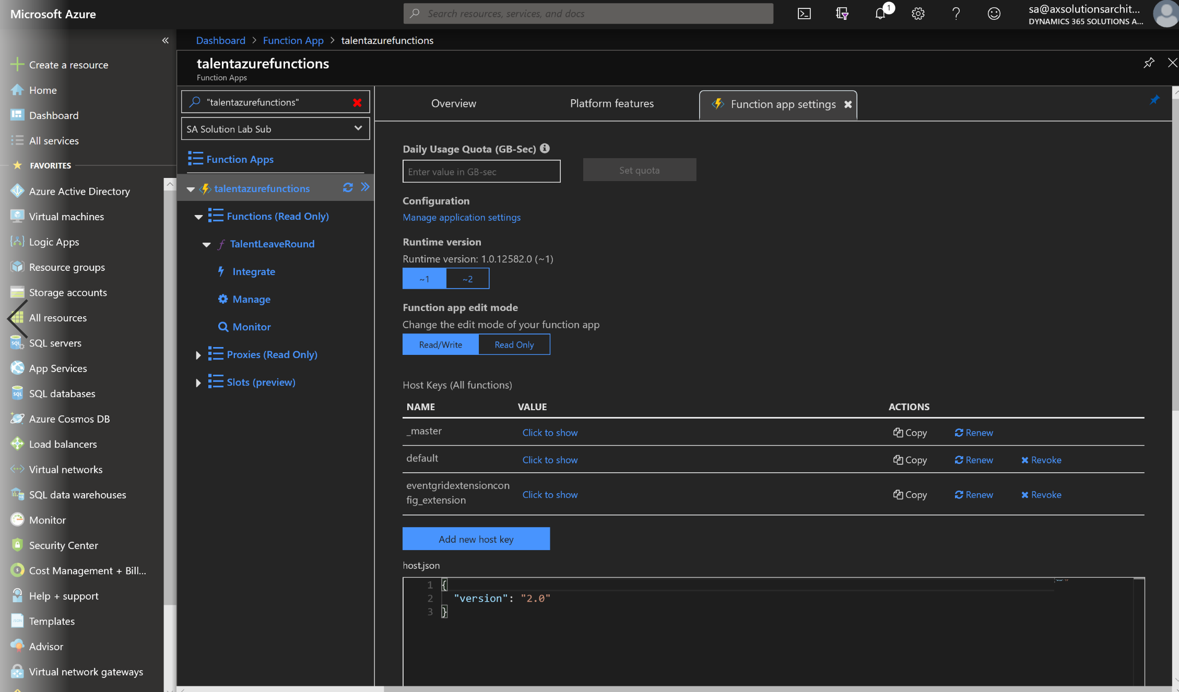

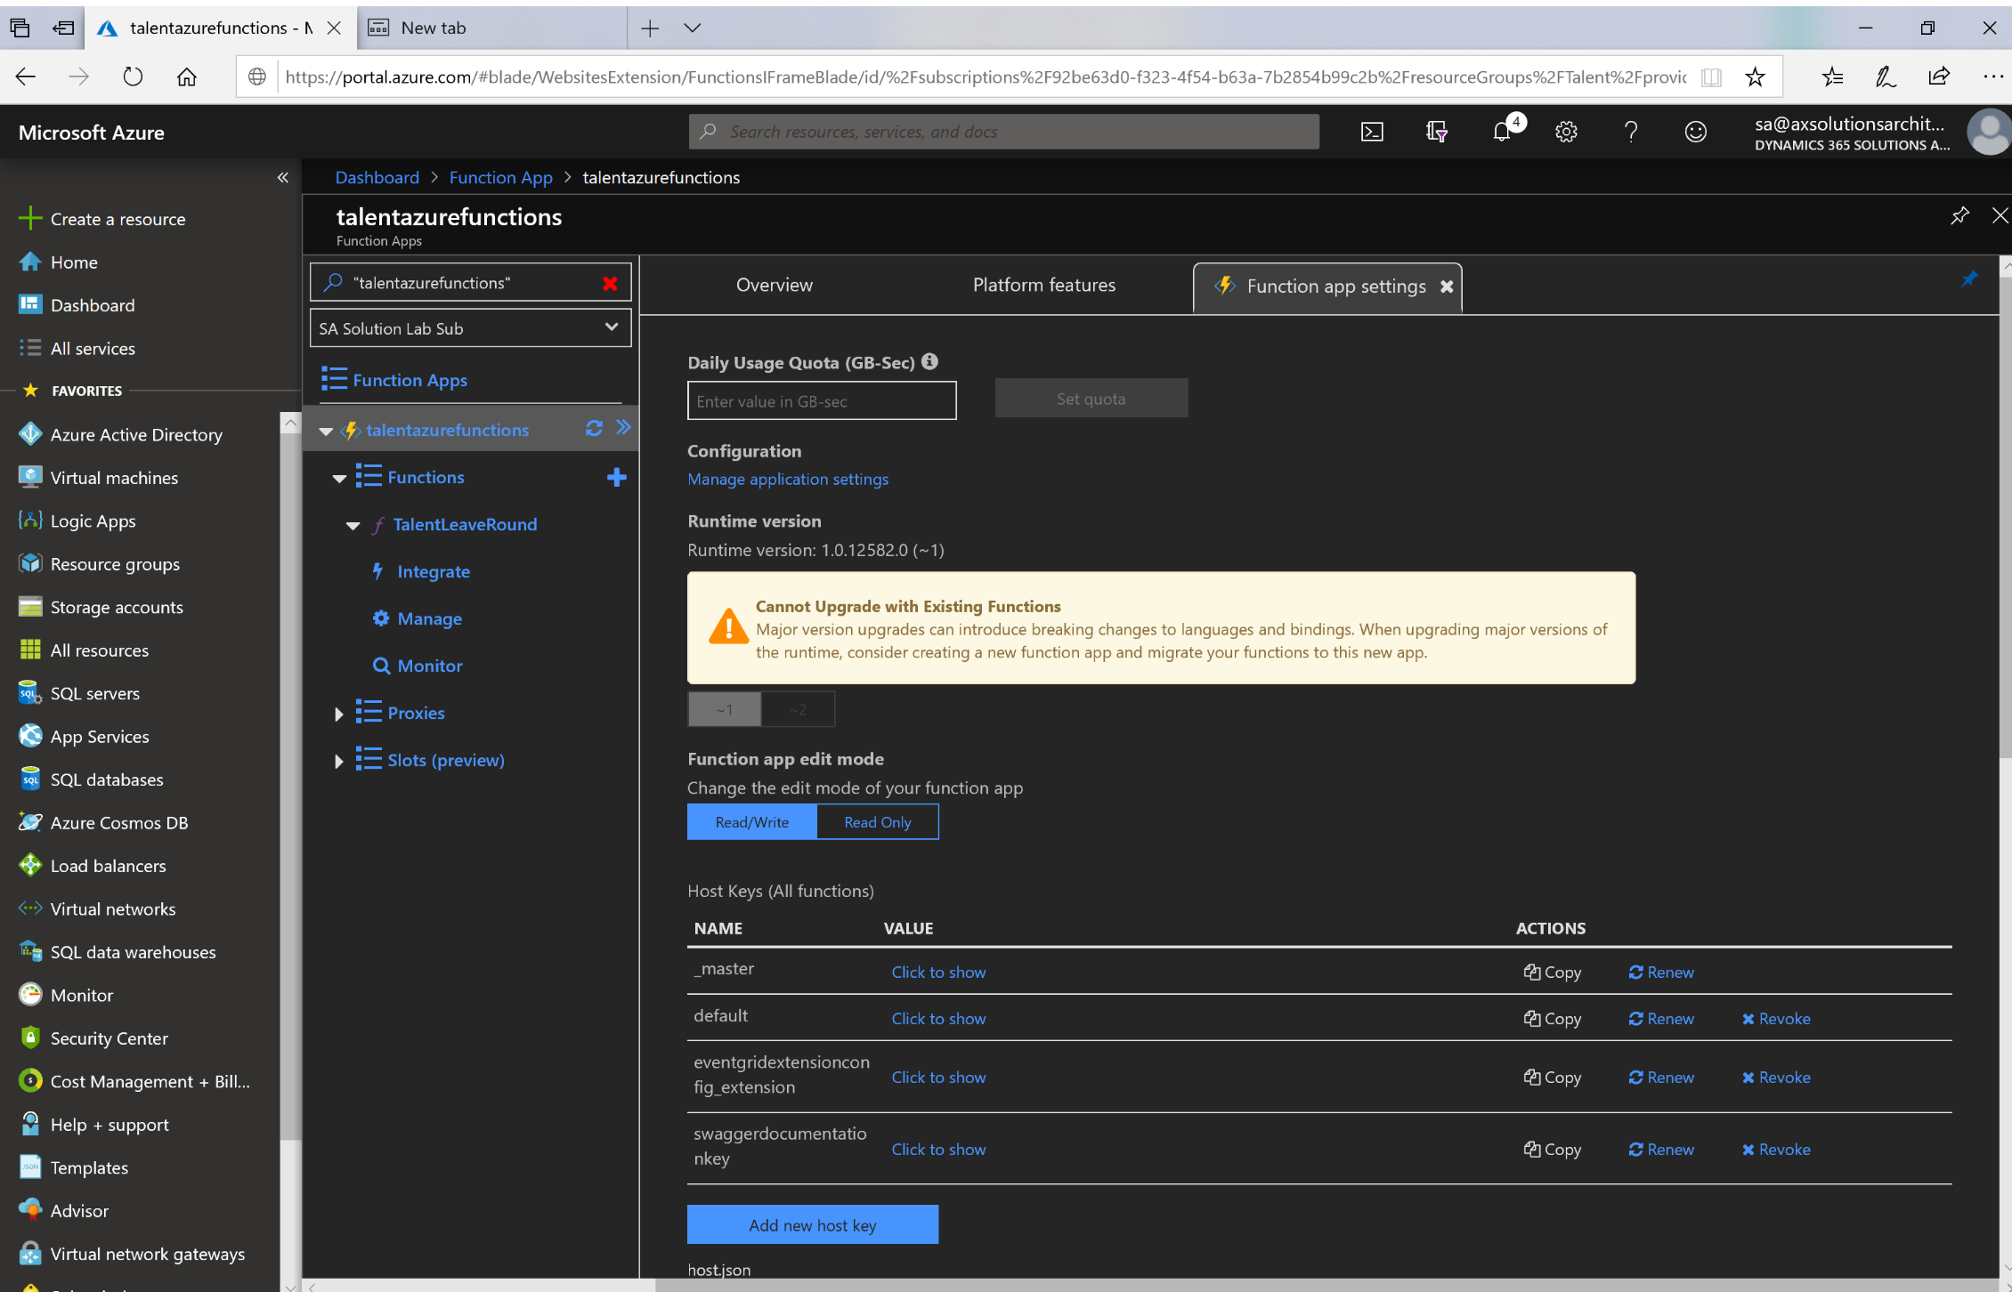

**Step 3: Define API and export to PowerApps and flow (Manually)**

Copy swagger file from deployment package to API definition ; Swagger file needs to be edited to add parameters required . you can edit or create Swagger in visual studio and copy it to Azure API definitipm.

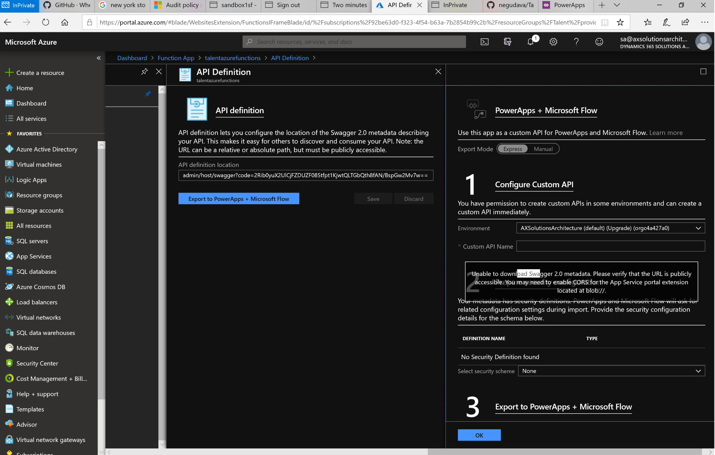

**Step4: Download the API definition**

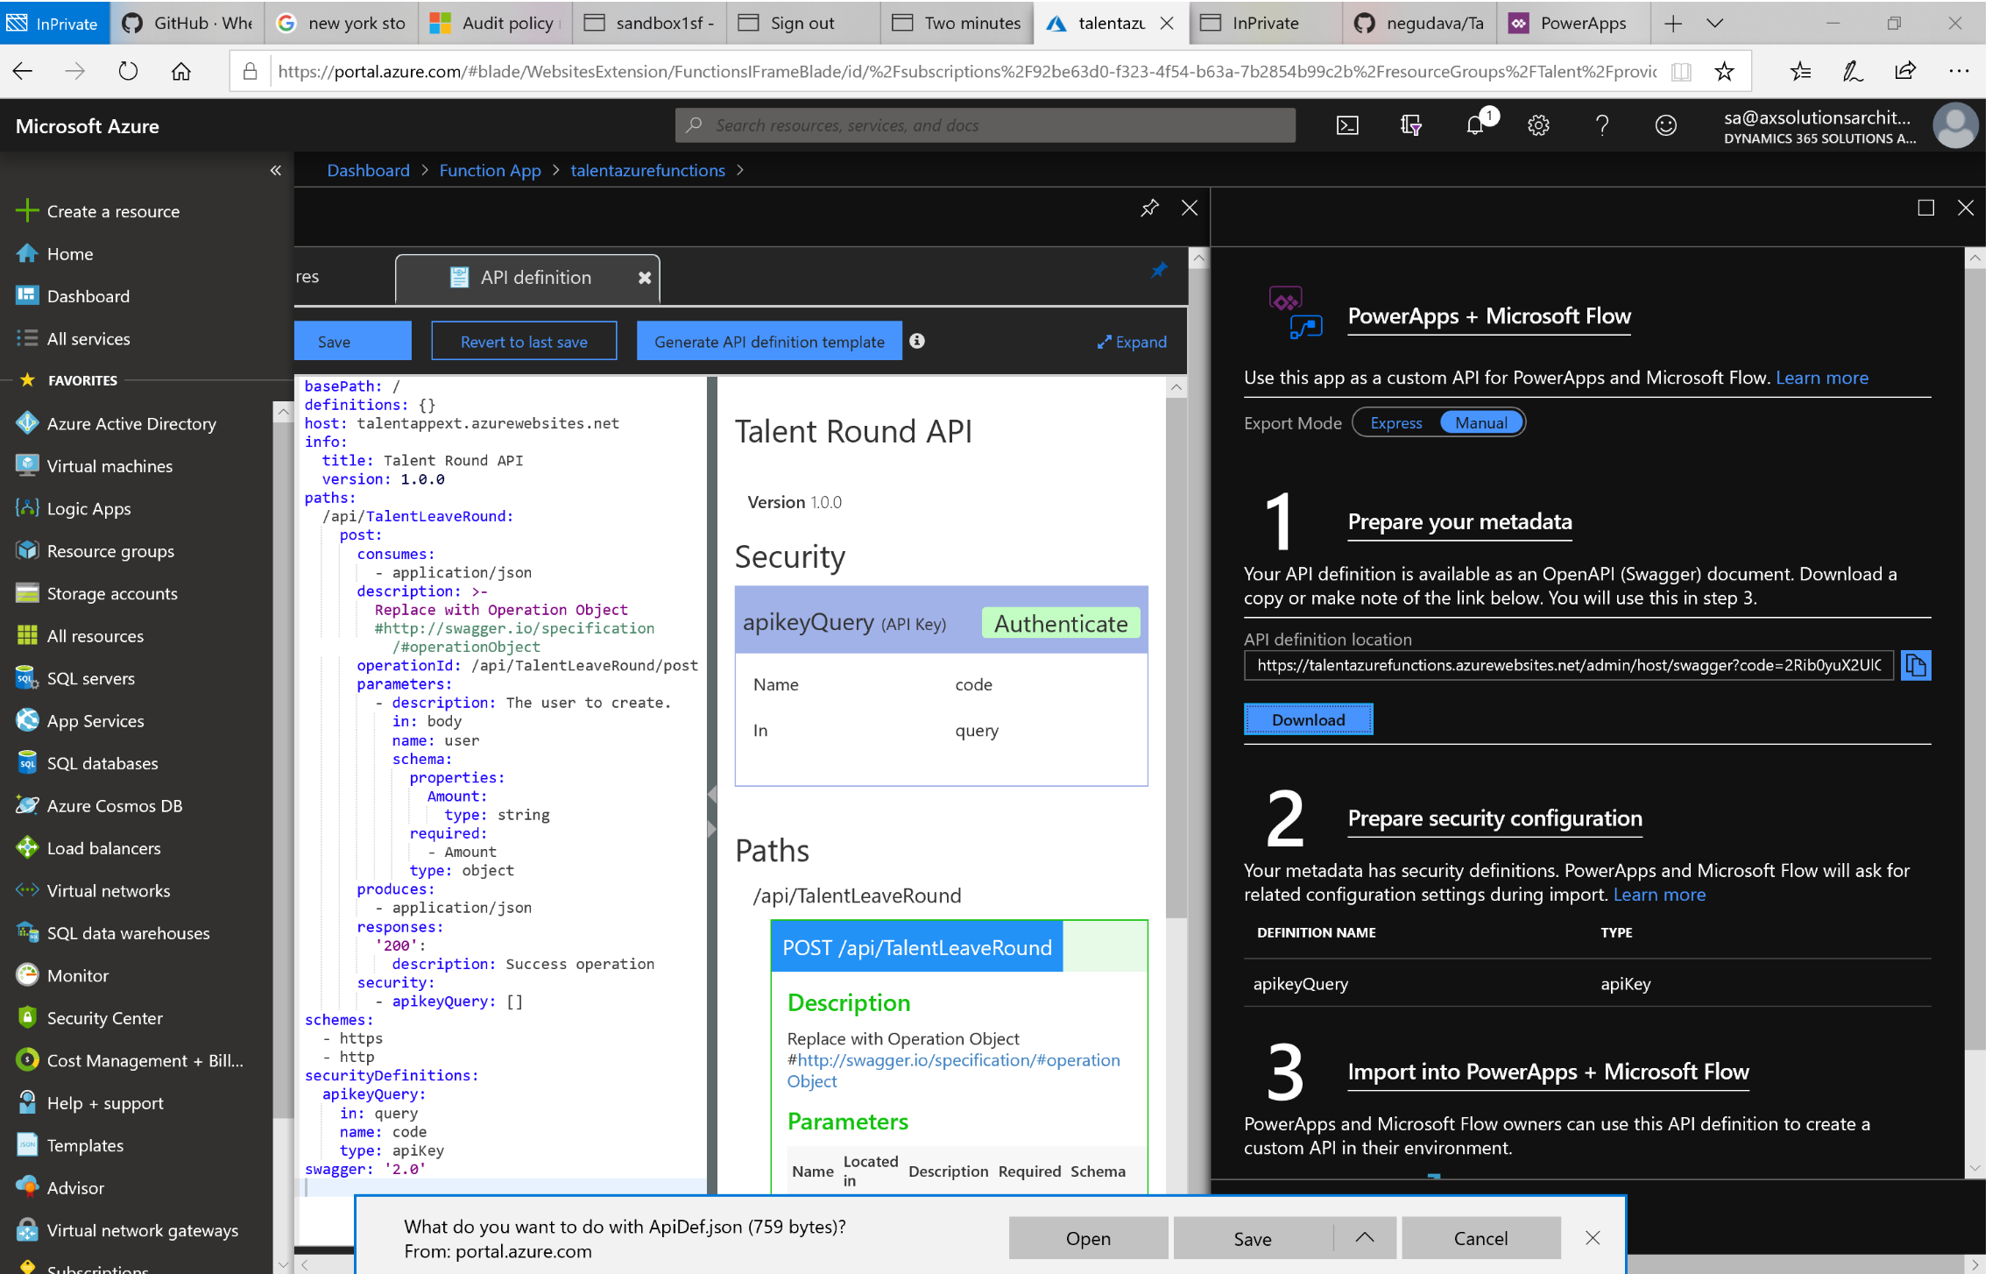

**Step 5: Create Custom Connector**

Upload the Open API file downloaded from previous step and call this connector in flow

